**Hands-On -1(Creation of first React App)**

**Step 1: Install create-react-app**

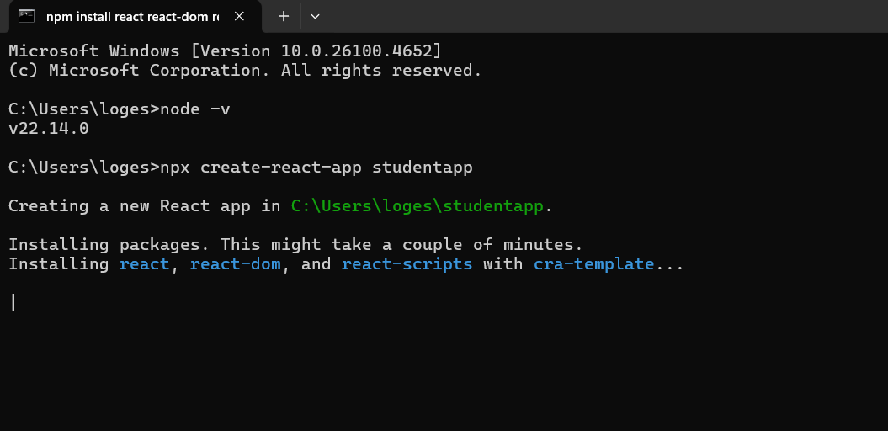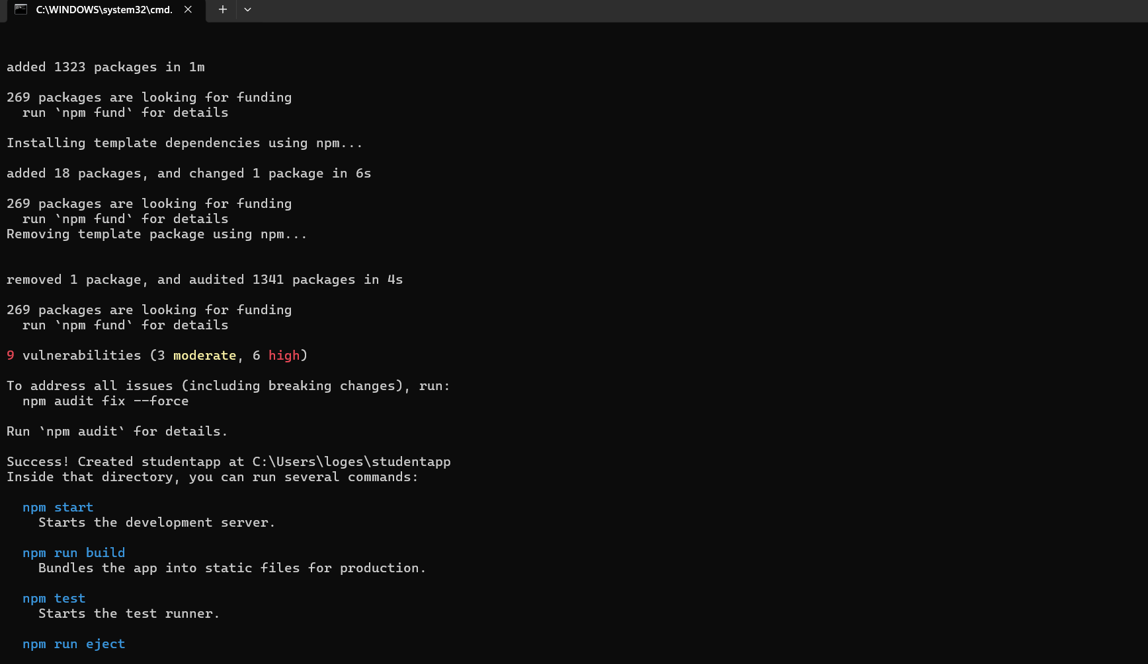

**Step 2: Modify App.js**

* **Go to src/App.js**
* **Delete all existing code**
* **Replace with the following**:

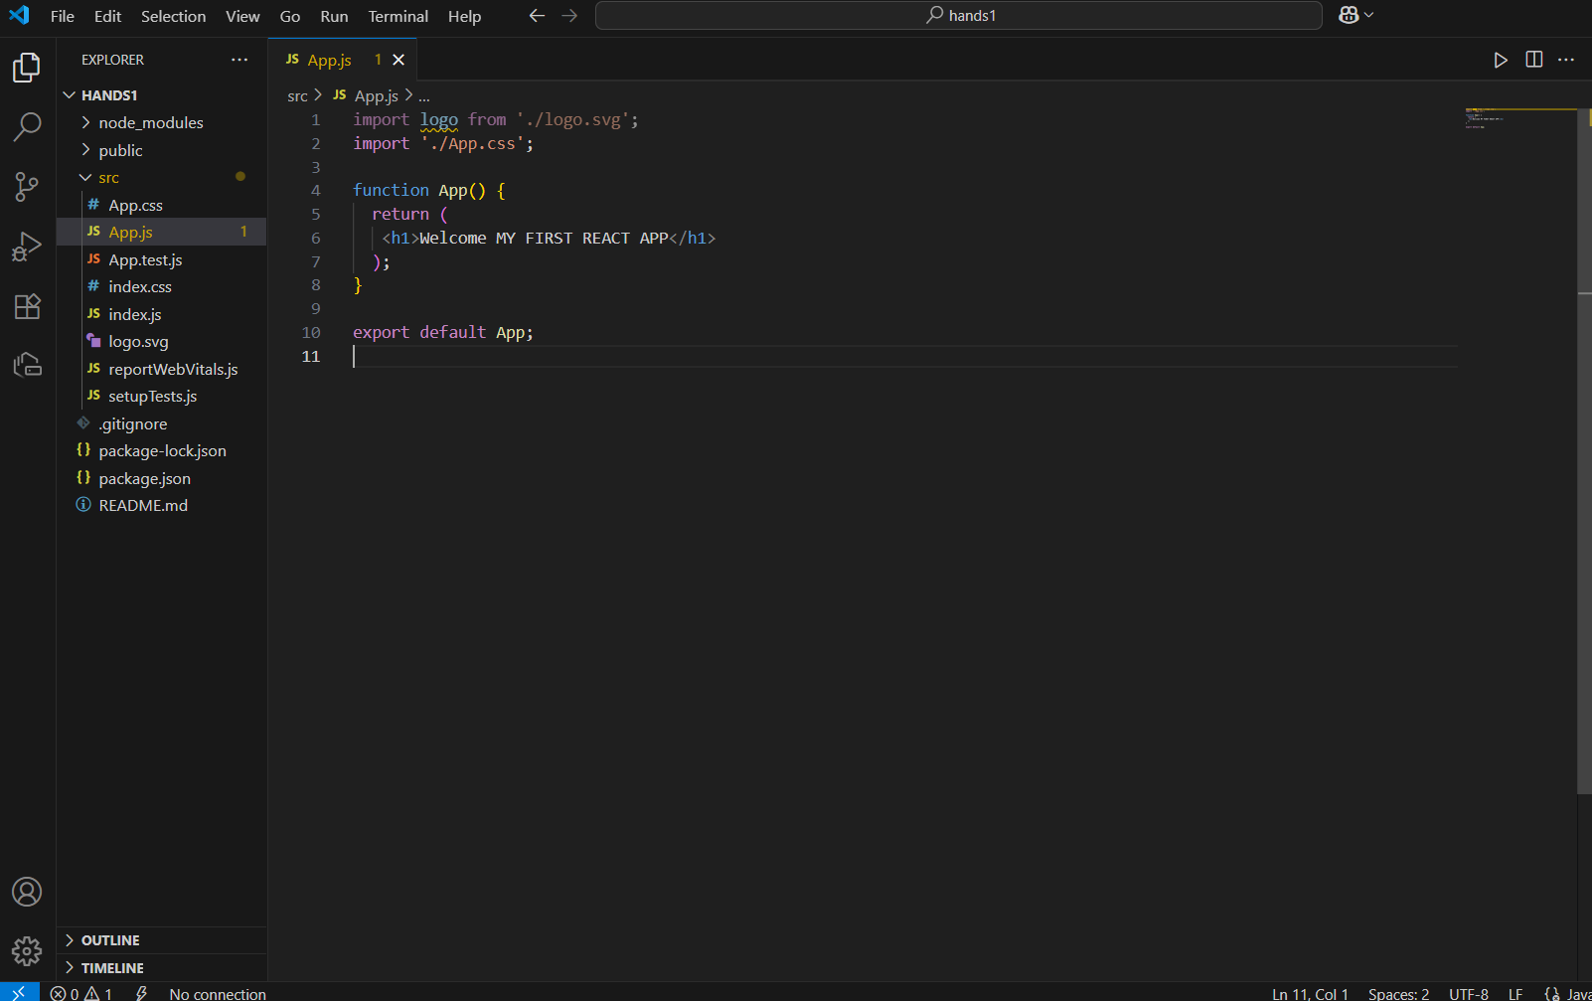

**Step 3:**

**Run the App:**

**>npm start**

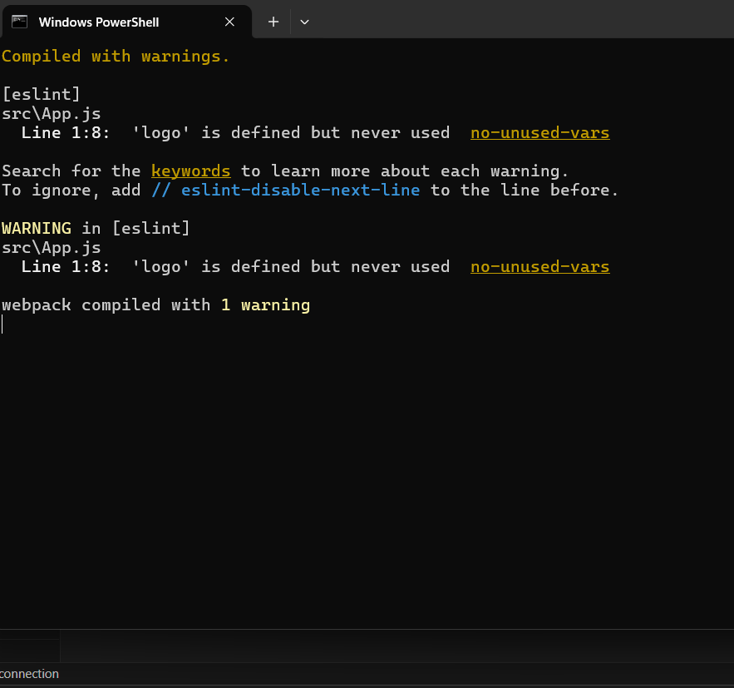

**Step 4:**

**Output in Browser:localhost:3001**

